Transition Document

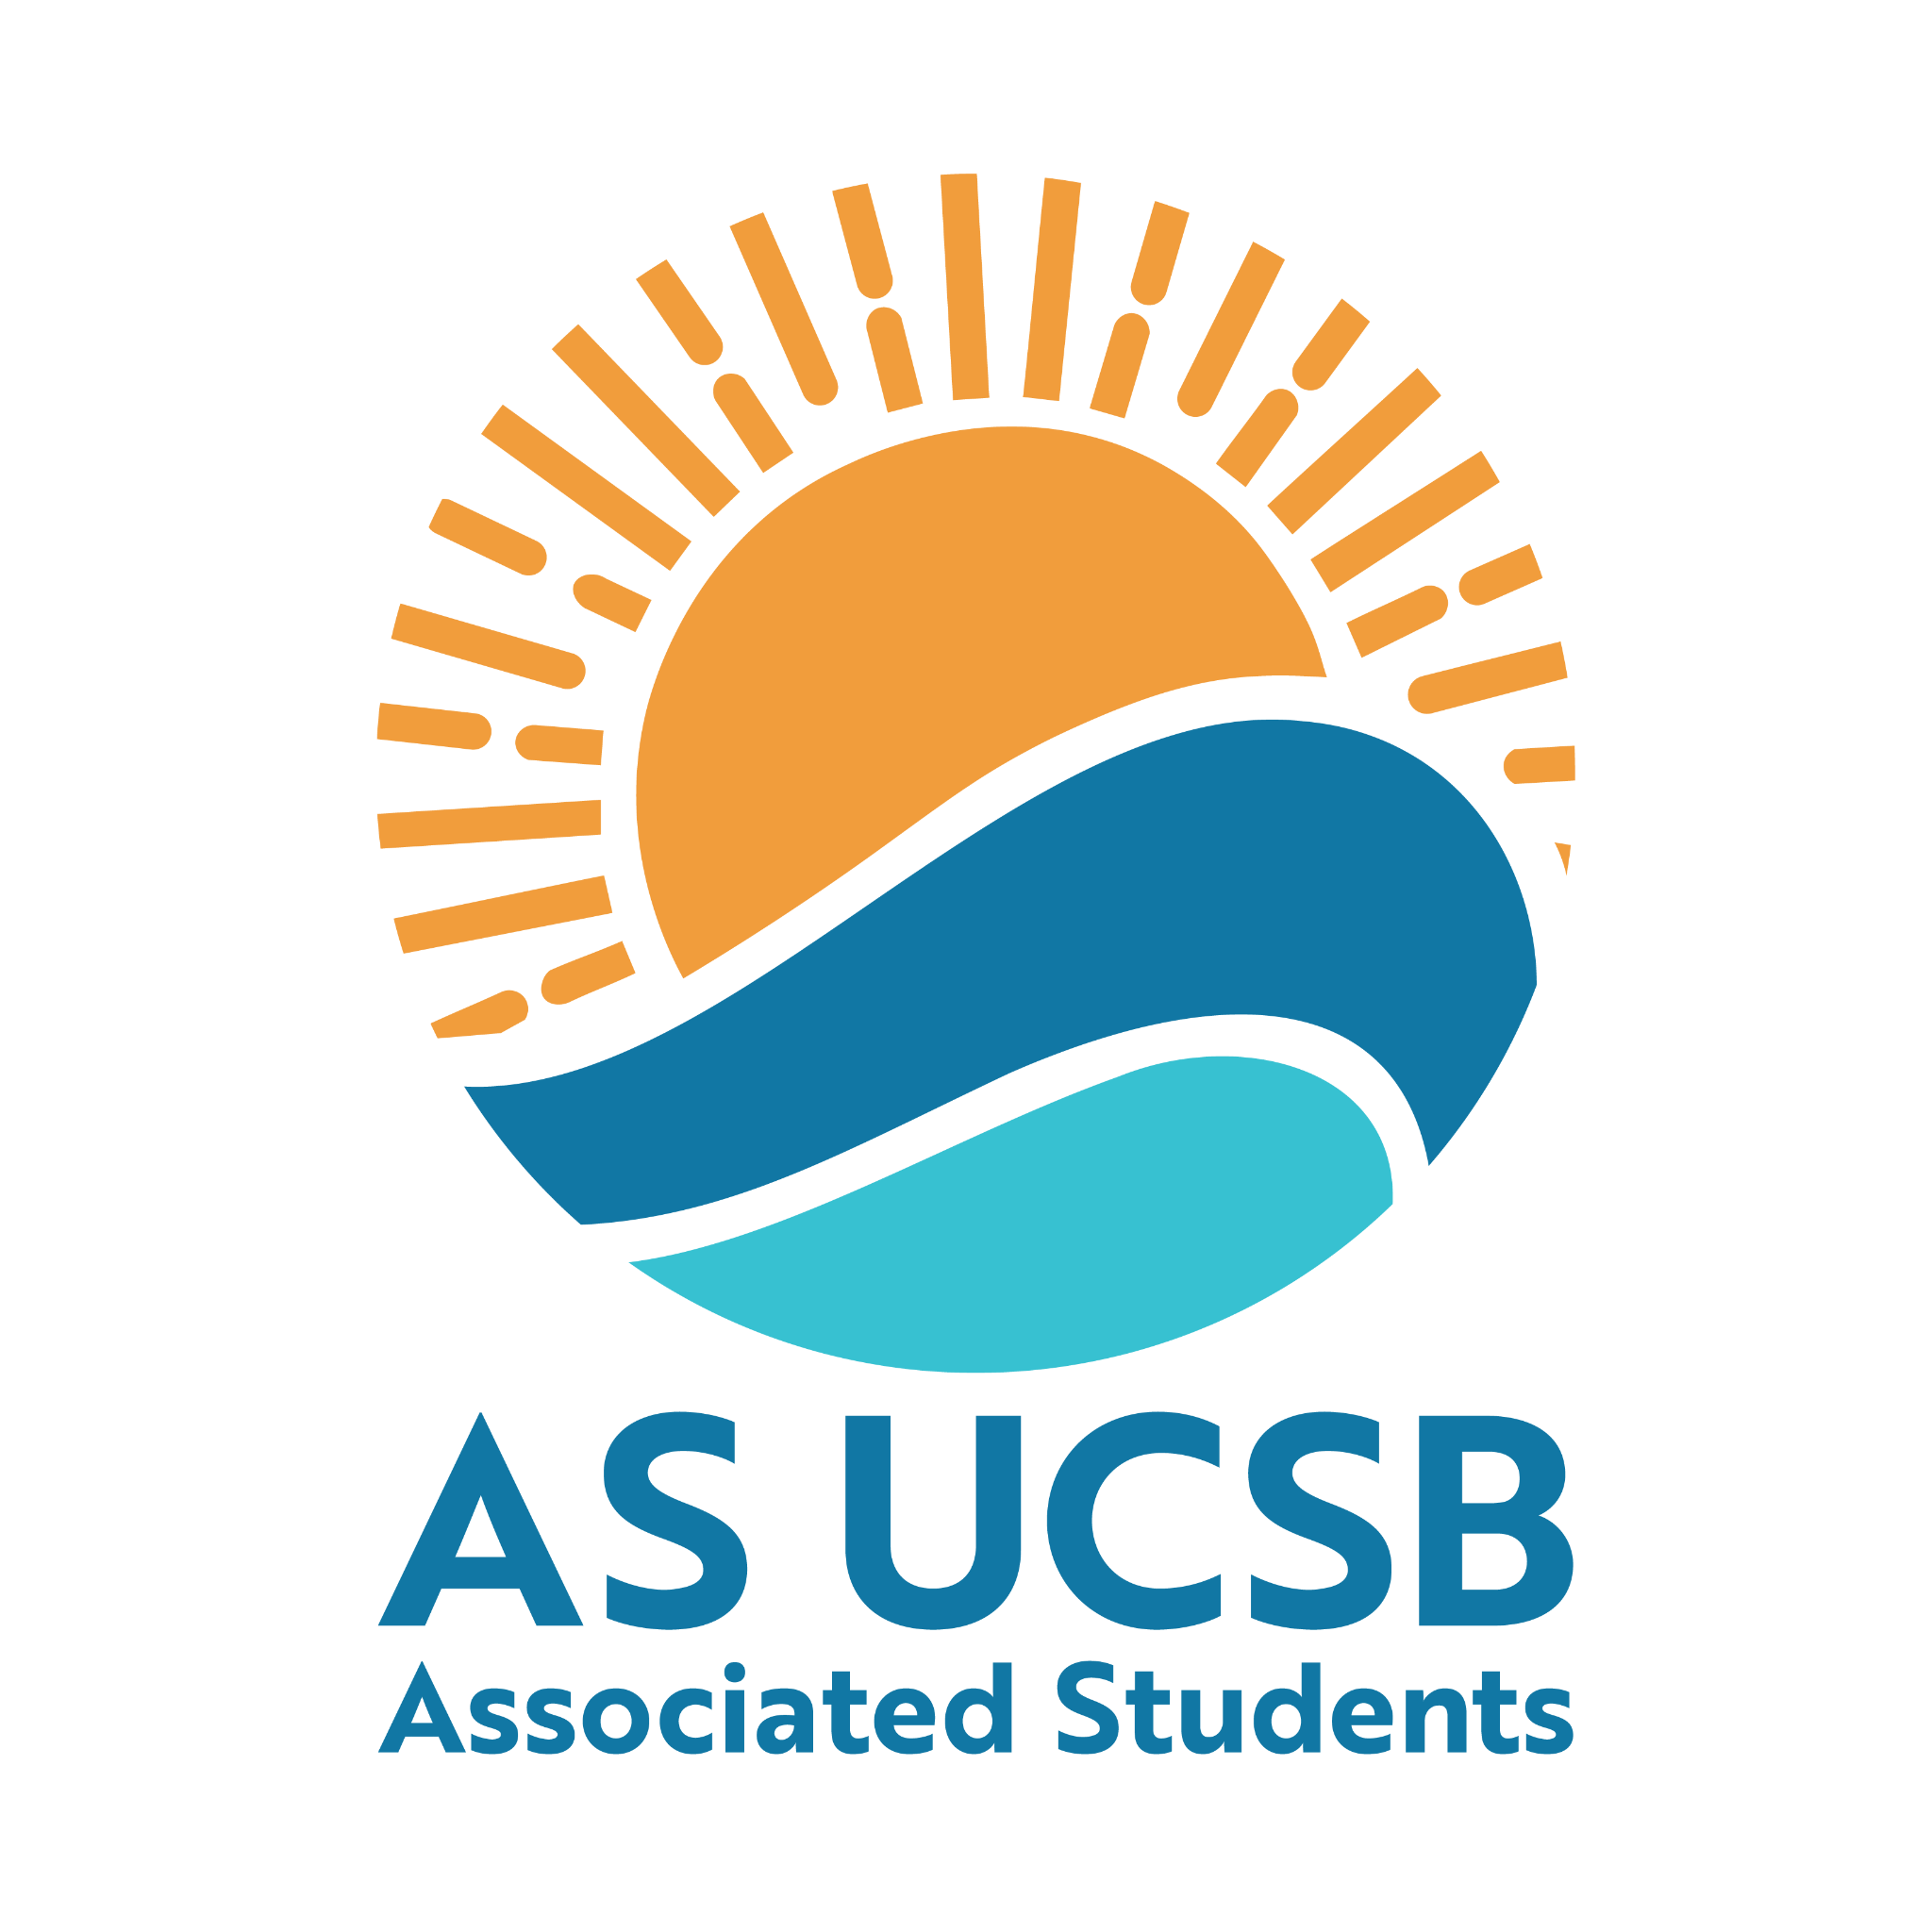

A.S. Committee on Committees Internal Liaison

Transition Report

2025-2026

Suggested elements to include:

Letter of Advice
- Congratulations on becoming the Internal Liaison for the Committee on Committees. This position is important because you help keep communication between CoC and the rest of Associated Students. A lot of the work is logistical, but it matters because it helps chairs stay informed, helps BCUs know what is expected of them, and helps students find open positions in A.S.
- My biggest advice is to stay organized and start early, especially with the Quarterly Chairs Meetings. These meetings happen near the beginning of each quarter, so it can feel difficult to get back into the rhythm of your duties right after a break. Once the Chairs Meeting is done, though, a large part of the quarter’s work is already handled, which makes the rest of the quarter feel more manageable.
- You do not need to know everything right away. A lot of the rol eis learning to navigate Google Drive, take minutes, manage spreadsheets, send reminders, track responses, and communicate with different people across A.S. At first, these processes may feel unfamiliar, but you definitely get more comfortable with them as the year goes on.
- This position is best for someone who manages their time well, communicates clearly, and genuinely cares about helping A.S. function better. A large part of the role is offering a helping hand when you can, even when something is not technically listed as one of your duties. Being willing to help other members with projects, events, communication, and logistics will make you much more effective in the role. One of my favorite pieces of advice that I received is that this, and any other role within Associated Students, is what you make of it.

Purpose of the Position
- The purpose of the Internal Liaison is to serve as a main communication point between the Committee on Committees and A.S. Boards, Commissions, Committees, and Units. In practice, this means keeping BCU chairs and vice chairs updated on important information, reminding entities to update their open positions and meeting information, helping coordinate Quarterly Chairs Meeting, and supporting broader communication within A.S.
- This role exists because A.S. is a large association with many different entities, and communication can easily become scattered. The Internal Liaison helps centralize information so that BCU chairs know what is happening, students can find available positions, and CoC can better support recruitment, collaboration, and transparency across the association.

Legal Code Duties
According to the A.S. Legal Code, the duties and responsibilities of the A.S. Internal Liaison are:
- Maintains active contact with the Boards and Committees Chairs and Vice Chairs to update them on any relevant information from the Committee on Committees. Contact Committee Chairs with information about appointments processes, recruitment events, and open positions.
- Coordinates a quarterly meeting of all A.S. Chairs outside of A.S. Assembly.
- Helps publicize A.S. Assembly to all A.S. entities.
- Holds at least three regular posted office hours per week.
- Collects each A.S. entity’s meeting time and location at the start of each quarter to be displayed online and in A.S. Main.
- Attends all meetings of the Committee on Committees and A.S. Assembly.
- Creates an annual A.S. Brochure that includes all A.S. entities.
- Coordinates with Creative Media to publish a quarterly newsletter of accomplishments of A.S. entities and the Association as a whole.
- Attends Board, Commission, Committee, and Unit meetings as necessary.
- Serves as an active member of the Committee on Honoraria.
- Develops curriculum for and coordinates A.S. Orientation for all Associated Students Officers.
- Fulfills other duties and responsibilities as assigned by the Chair.

Email
- The email associated with this role is: ASTD Internal Liaison COC
  - Password: IL202324_mno
- This email is important for communicating with BCU chairs and vice chairs, sending reminders about Quarterly Chairs Meeting, following up about open positions, and maintaining communication between CoC and other A.S. entities.
- I recommend checking this email regularly, especially at the beginning of each quarter when you are planning the Chairs Meeting, collecting BCU meeting times, and reminding chairs to update their open positions. All of your A.S. related work should be done through this email.

Event Ideas / What I Did in the Role

Quarterly Chairs Meetings
I joined after the Fall Quarter Chairs Meeting, so I organized the Winter and Spring Quarterly Chairs Meetings. These meetings are one of the most important responsibilities of the Internal Liaison.
For Spring, the meeting was scheduled for:
Monday, April 6, 2026
6:00–7:00 PM
UCEN Flying A Room
Dinner catered
Attendance required for BCU representation
The purpose of these meetings is to bring A.S. chairs together, share important updates, remind BCUs of expectations, and create space for collaboration across the association. These meetings also give chairs the chance to get to know each other and potentially inspire collaboration between entities.
Attendance was pretty good, but it is definitely something that can be improved. The biggest recommendation I have is to start reminders earlier than we usually do. Make sure chairs understand why the meeting matters and emphasize that attendance is expected. It also helps to make the meeting feel welcoming, useful, and worth attending. Free food is honestly a good incentive, so make sure to mention dinner in the reminders.
For future Chairs Meetings, I recommend:
- Start planning immediately at the beginning of the quarter.
- Reserve the room early.
- Confirm food/catering as soon as possible.
- Send reminders earlier and more consistently.
- Make the RSVP form clear and easy to complete.
- Stress the importance of attendance.
- Emphasize free food/dinner.
- Make the presentation useful and engaging.
- Leave space for chairs to ask questions.
- Create a welcoming environment so people actually want to come.
The presentations are helpful because they allow chairs to learn about each other, understand what is happening across A.S., and potentially build collaborations. The main thing to improve is attendance and making sure chairs see the meeting as valuable.

Open Positions Spreadsheet and Website Updates
The Open A.S. Positions Recruitment Spreadsheet is one of the most important parts of the job. It should be treated as a central communication tool for available positions across A.S. A major challenge this year was getting BCU chairs to actually update the spreadsheet. This is something the next board should continue working on.
The CoC website should also be kept up to date alongside the spreadsheet. This takes a lot of manual work because not every BCU updates their open positions correctly or consistently. However, keeping the website updated should be one of the main priorities going into next year. Ideally, the open positions spreadsheet and CoC website should become the central places students go to find available A.S. positions.
This work can feel tedious, but it is really important. When the spreadsheet and website are updated, it makes A.S. more accessible to students who want to get involved.

Creative Media / Communication Work
I met with Creative Media a couple of times to communicate each other’s needs and figure out how we could work together to improve communication within the association. This is something I recommend continuing. Creative Media can be a helpful partner for newsletters, brochures, publicity, and making information more accessible to students.
Even if a project is not fully completed, maintaining communication with CMU is still valuable because it helps create a stronger relationship between CoC and the people who support A.S. communications.

Events / What I Did in the Role
During my time as Internal Liaison, I worked on:
- Organizing the Winter and Spring Quarterly Chairs Meetings.
- Sending reminders to BCU chairs and vice chairs.
- Tracking RSVPs and attendance for Chairs Meetings.
- Helping chairs update the Open A.S. Positions Recruitment Spreadsheet.
- Helping update the CoC website alongside other CoC members.
- Communicating with BCU chairs about open positions, meeting times, and expectations.
- Meeting with Creative Media to discuss communication needs within A.S.
- Helping with the A.S. Careers Fair / tabling.
- Helping Mira and Rylee with Committees Café.
- Supporting CoC members with projects and logistics when needed.
A big part of the role is being willing to help out when you can. Not every responsibility will be clearly written in Legal Code, but being a reliable person on the board makes the role much more meaningful and useful.

What Went Well
The Winter and Spring Chairs Meetings went well overall. Attendance was pretty good, and the presentations were helpful for giving chairs important updates and creating space for them to connect with each other. I also think the meetings were useful because they gave chairs the chance to hear directly from CoC and understand what information needed to be updated.
The open positions work was also important. Even though getting chairs to update the spreadsheet was difficult, the work itself was valuable because it helped move CoC closer to having one central place for available A.S. positions.
Meeting with Creative Media also went well because it helped create more communication between CoC and CMU. This is a relationship that should continue because it can help with publicity, newsletters, and improving communication across the association.

What Could Be Improved
The biggest thing that could be improved is attendance at Quarterly Chairs Meetings. Chairs are busy, and it can be difficult to get everyone to attend, but earlier and more consistent reminders would help. It is also important to stress why the meeting matters and what chairs will gain from attending.
The Open A.S. Positions Recruitment Spreadsheet also needs continued attention. Many BCUs do not update their open positions consistently, which makes it harder for CoC to maintain accurate information. The next Internal Liaison should make this a major priority and follow up with chairs regularly.
The CoC website should also be updated more consistently. This will take manual work, but it is worth it because students should be able to rely on the website as an accurate place to find opportunities in A.S.

Unfinished projects?
Going into next year, keeping the CoC website up to date should be one of the main priorities of the board. This is meticulous work, and many BCUs do not update their open positions accordingly, so it will require consistent follow-up and manual updating.
The Open A.S. Positions Recruitment Spreadsheet should also continue to be improved. Ideally, the spreadsheet and the CoC website should serve as the central place of communication for available A.S. positions. This would make the recruitment process clearer, more organized, and more accessible for students who want to get involved in A.S.
I recommend that the next Internal Liaison prioritize the following in the first few weeks:
- Plan the Quarterly Chairs Meeting.
- Confirm the room, food, RSVP form, and presentation.
- Send early reminders to all chairs and vice chairs.
- Remind BCUs to update their open positions.
- Collect updated meeting times and locations.
- Help make sure the CoC website reflects current open positions.
- Communicate with the Chair and other CoC members about what needs to be updated.

Important Resources

CoC Google Drive
  - The Google Drive is one of the most important resources for this role. It should contain past documents, meeting materials, contacts, agendas, minutes, and other transition information. Spend time getting familiar with it early.

Open A.S. Positions Recruitment Spreadsheet
  - This spreadsheet is essential for tracking available positions across A.S. It should be updated regularly and should ideally serve as one of the main resources for students looking to join A.S.

CoC Website
  - The website should reflect current open positions and important CoC information. Keeping it updated is time-consuming but very important.

A.S. Main
  - A.S. Main is important because meeting times and locations should be displayed there. It is also a central place to connect with other A.S. members and staff.

Creative Media
  - Creative Media can help with publicity, newsletters, graphics, communication, and broader outreach. Maintaining a good relationship with CMU will make communication projects easier.

Past Chairs Meeting Materials
  - Look through past slides, RSVP forms, emails, attendance trackers, and agendas before planning your own Chairs Meeting. Reusing and improving past materials will save a lot of time.

Important Contacts

Most of the contacts you will need are available in the CoC Drive. If you need a contact and cannot find it, ask the Chair or another person familiar with who you are trying to contact. People in A.S. are usually happy to help.

